**Data Serialization and Exchange over Network_**

1. Refer “little_big_endian_converter.c”. Implement the below functions and test.

int swap_int32(int val); // swap the bytes in input and convert from little to big endian

void showbytes(char *value, int n); // display n bytes starting from given address

A: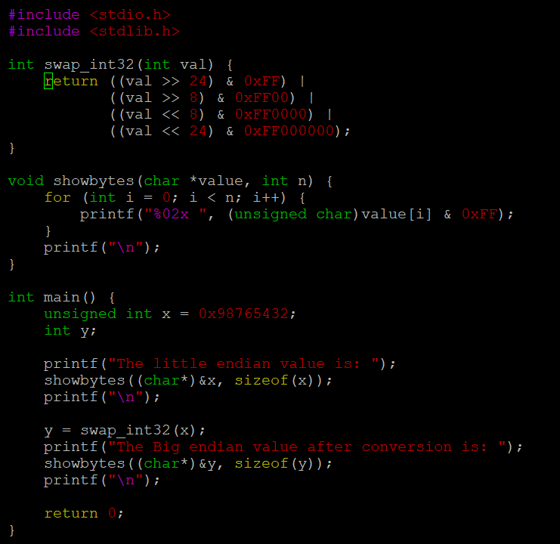

1. Write a program to detect and display the endianness of the processor.

